**TASK 1**

**Objective: Flow chart Programming**

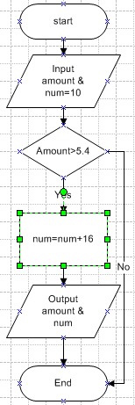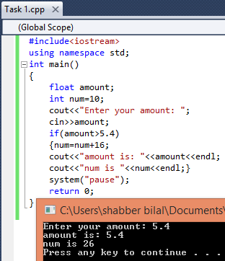Write a C++ Program that read a float input from user and store it in variable amount. Add 16 to an integer num if the value of amount in greater than 5.4. Print out the results of both variables on screen.

**Pseudo Code**

Start

Input amount & num=10

If ( Amount>5.4)

Num=num+16

Output amount & num

End

**TASK 2**

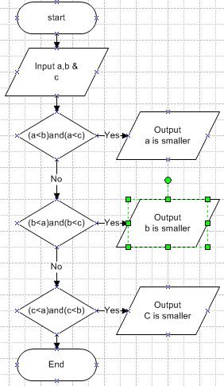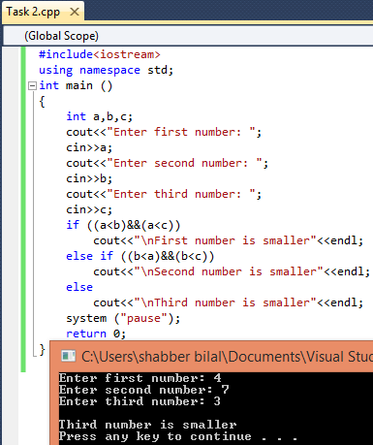**Objective: Flow chart Programming**

Write a C++ Program that read three input from user and returns the smallest one.

**Pseudo Code**

Start

Input a, b & c

If (a<b)and(a<c)

Output First number is smaller

Ele if (b<a)and(b<c)

Output Second number is smaller

Else (c<b)and(c<a)

Output Third number is smaller

End

**TASK 3**

**Objective: Flow chart Programming**

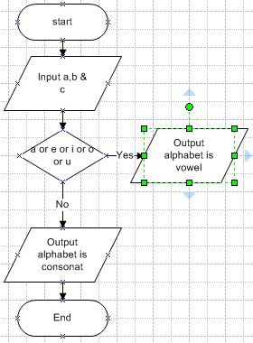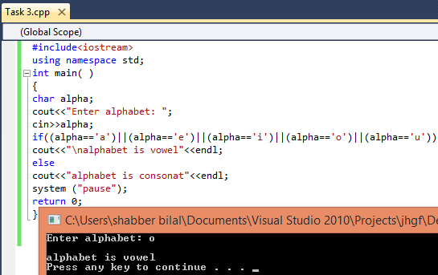Write a C++ Program that read an alphabet (e.g. a,b,c,d,…..z) and display whether the input alphabet is a vowel (i.e. a, e, i, o, u) or consonant( alphabets other than vowels).

**Pseudo Code**

Start

Input alphabet

If (alpha=a or alpha=e or

alpha=i or alpha=o or

alpha=u)

Output alphabet is vowel

Else

Output (alphabet is

consonat)

Else

**TASK 4**

**Objective: Flow chart Programming**

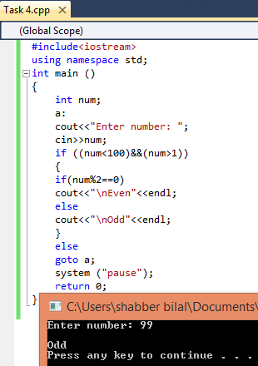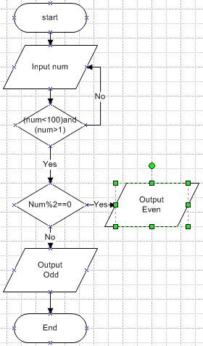Write a C++ Program that read a number from user (1-100),if the number is below 1 or above 100, ask user to enter new value. Then test the user entered number whether it is EVEN or ODD. Print the message that number is EVEN or ODD.

**Pseudo Code**

Start

a

Input num

If (num<100)&(num>1)

{if (num%2=0)

Output Even

Else Odd}

Else goto a

End

**TASK 5**

**Objective:**

Write a C++ Program that read an integer input in between (1 to 12) and store it month_of_year. Print the corresponding month of year. Use nested else if statement. Example: Input is 4… Print “April”

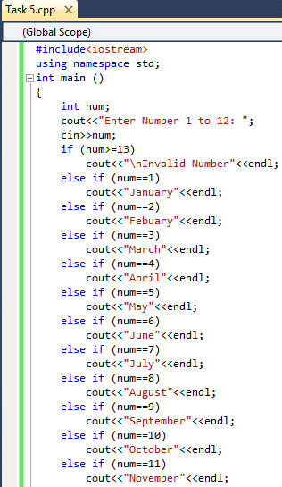 **Flow chart Programming**

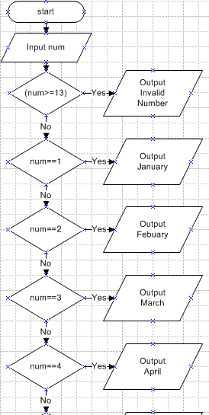

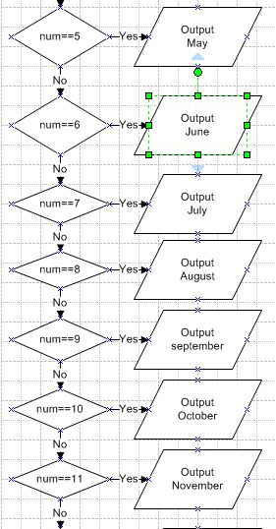

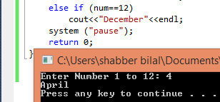

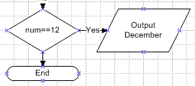

**TASK 6**

**Objective:**

Write a C++ Program that read an integer input in between (1 to 12) and store it month_of_year. Print the corresponding month of year. Example: Input is 4… Print “April”. using switch statement.

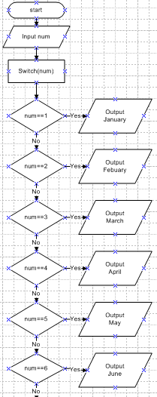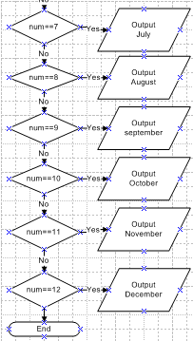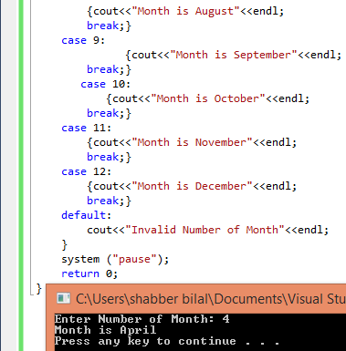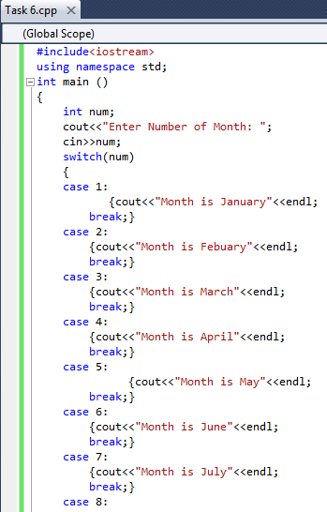  **Flow chart Programming**